**Course: Power BI and Tableau**

**Assignment 1**

Candidate Name – Arpit Vijay

Mail ID – [arpit.vijay1995@gmail.com](mailto:arpit.vijay1995@gmail.com)

Part 1: Screenshot of the Report View in Power BI Desktop

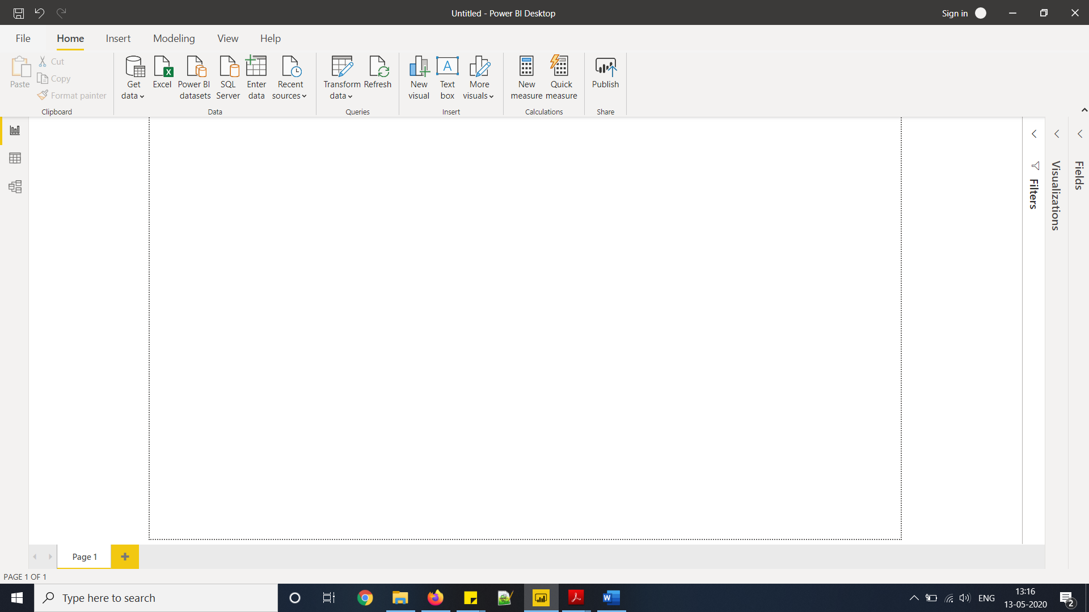

Part 2: Screenshots of

* Report View

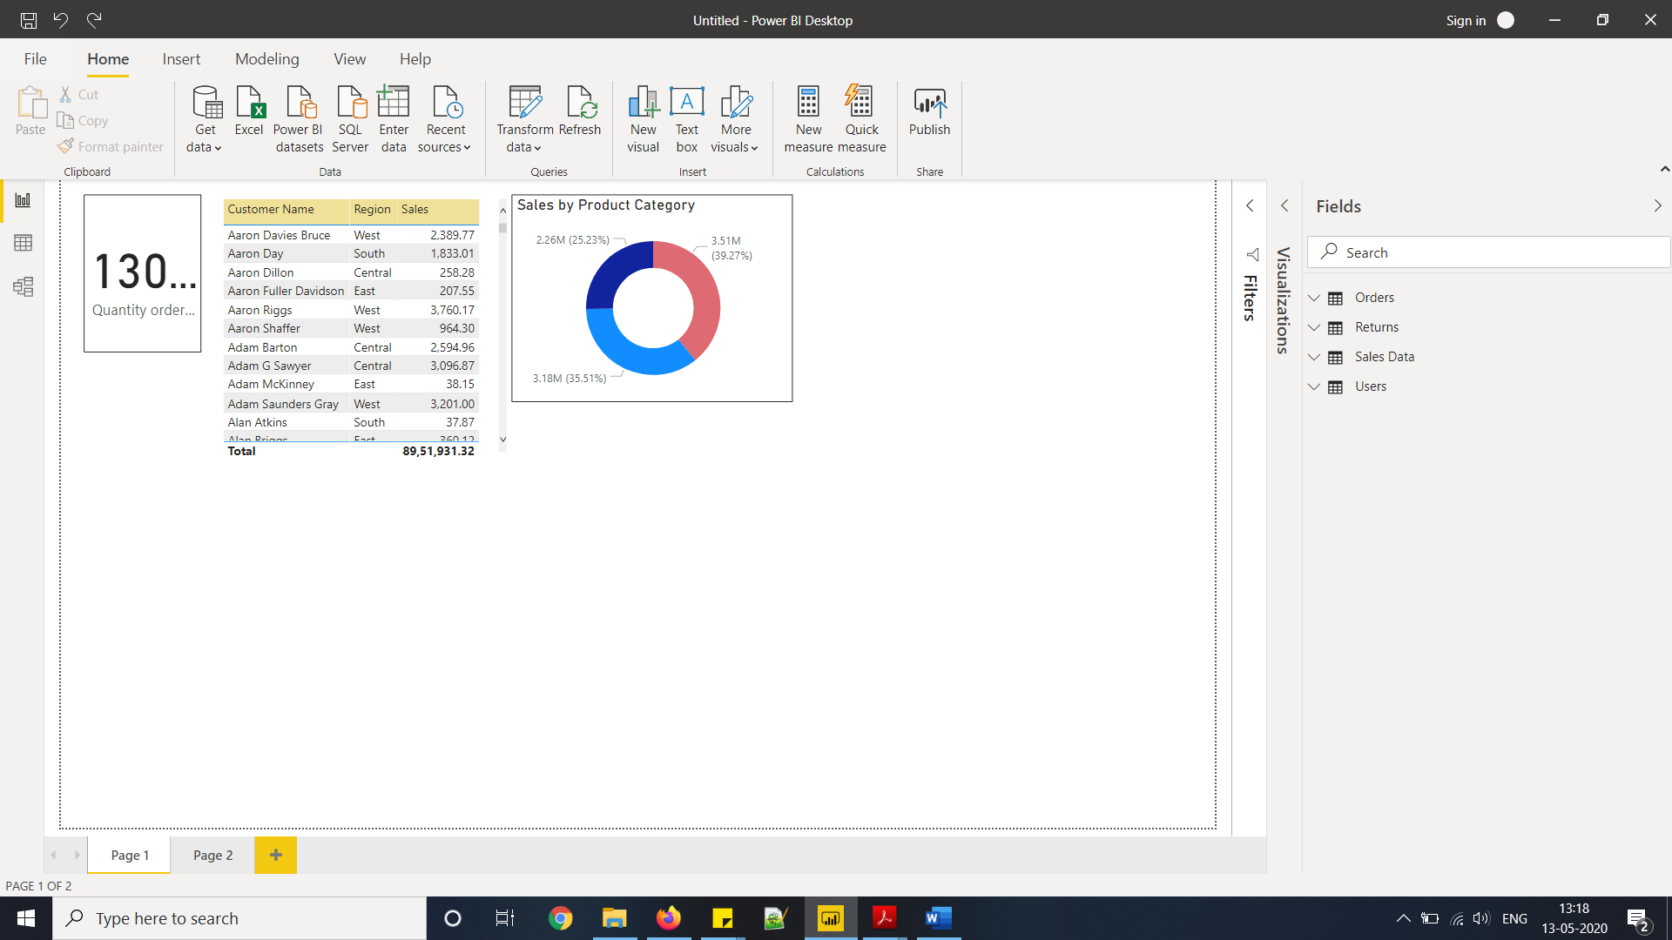

* Data View

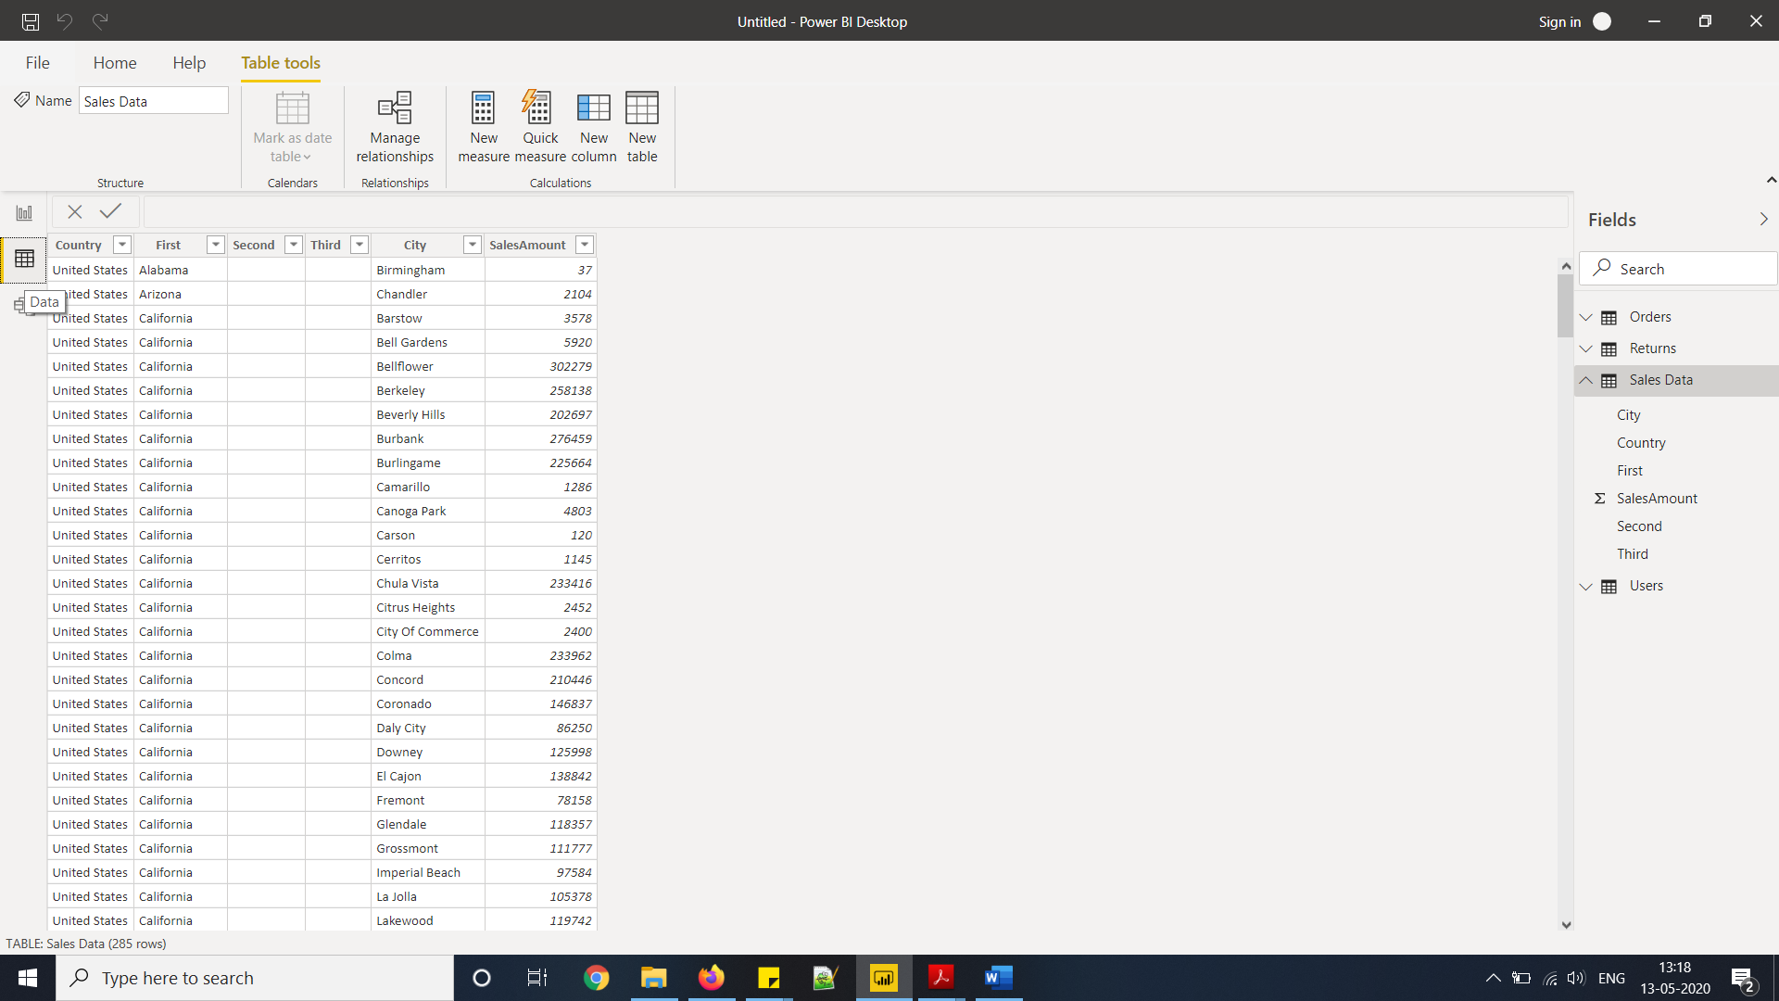

* Model View

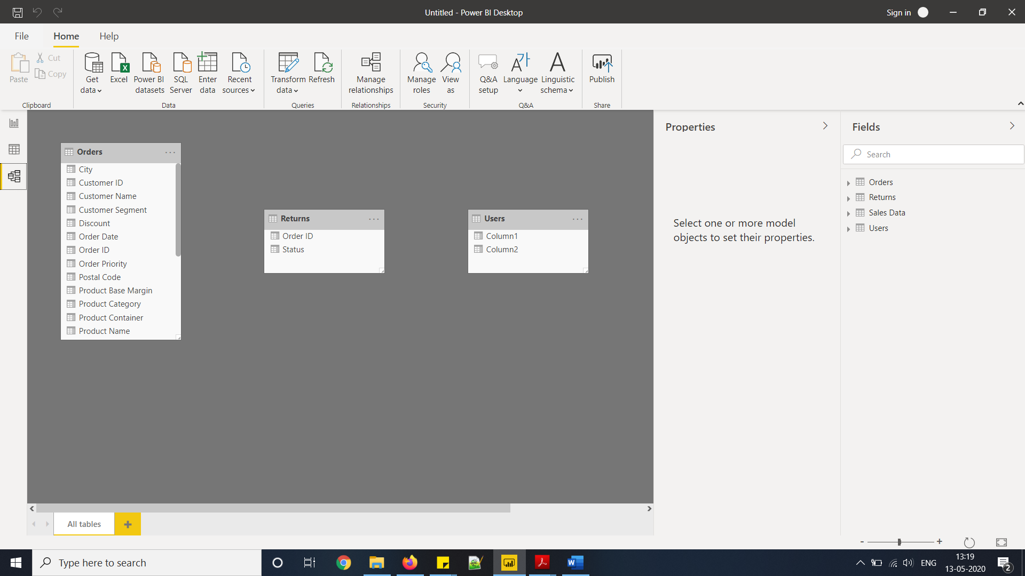

* Power Query Editor

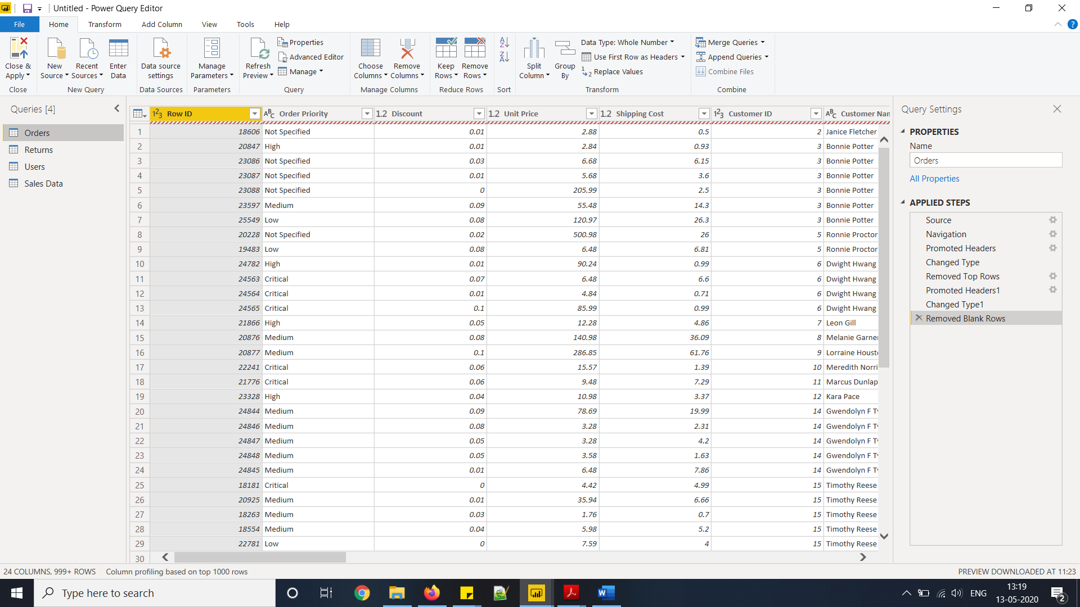

* Advance Editor

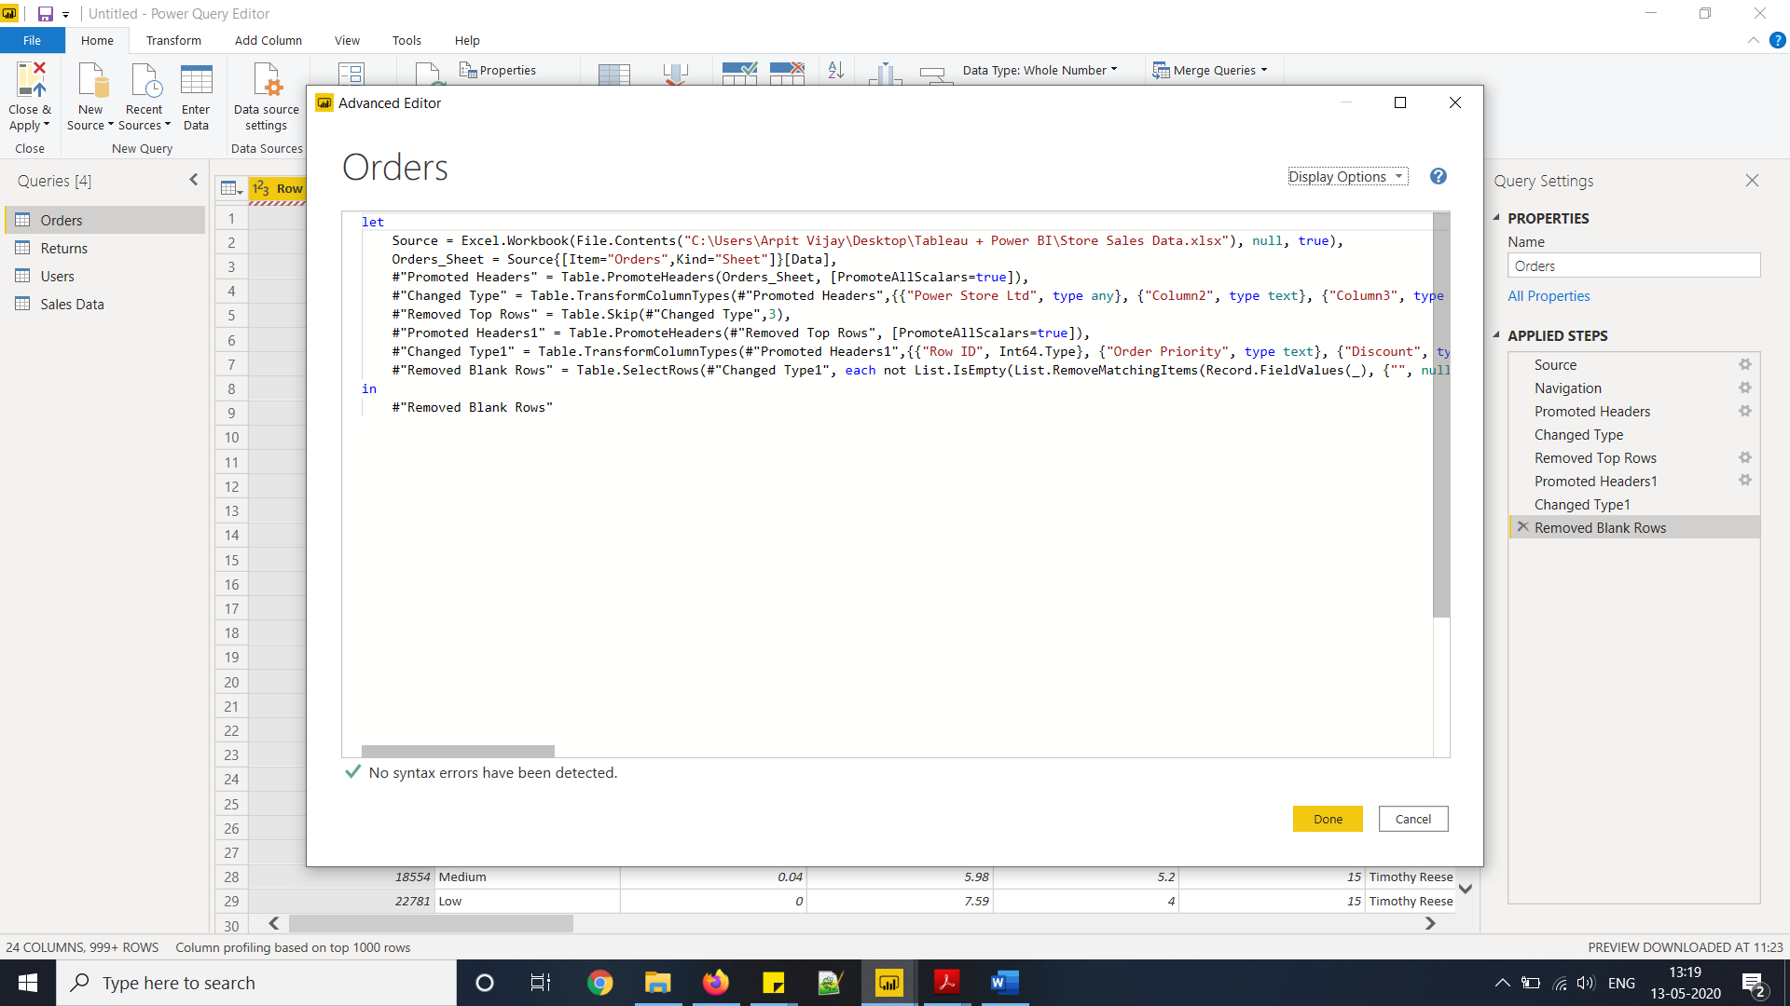

Part 3: Power BI Pricing

|  |  |  |  |  |
| --- | --- | --- | --- | --- |
| **S. No.** | **Power BI Version** | **User type** | **Monthly Price ($)** | **Monthly Price (₹)** |
| 1. | Desktop | Individual | Free | Free |
| 2. | Pro | Individual | 9.99 | 660 |
| 3. | Premium | Dedicated cloud compute | 4,995 | 3,30,190 |